Lab Exercise 5 - Template Invocators and Steps Template Serial in Argo Workflows

Objective
In this lab, you will learn how Argo Workflows invokes templates using:
- Steps Template
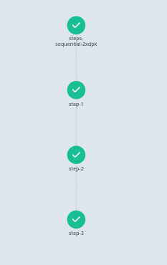

What are Template Invocators?
A Template Invocator is a mechanism used by Argo to call or execute another template.
Instead of placing all logic in a single template, Argo allows templates to invoke other templates.
Benefits:
- Reusability
- Better workflow organization
- Easier maintenance
- Complex workflow orchestration

Types of Template Invocators
Invocator | Purpose
Steps | Sequential or Parallel execution
DAG | Dependency-based execution
Template Reference | Call another template
Workflow Template Reference | Call templates from WorkflowTemplate

Steps Template Invocator (Sequential Execution)
Objective
Execute multiple templates one after another.

Create Workflow
Create file:
steps-sequential.yaml

Paste:
apiVersion: argoproj.io/v1alpha1
kind: Workflow
metadata:
generateName: steps-sequential-
spec:
entrypoint: main
templates:
- name: main
steps:
- - name: step-1
template: first-step
- - name: step-2
template: second-step
- - name: step-3
template: third-step
- name: first-step
container:
image: alpine:3.20
command: [echo]
args: ["Executing First Step"]
- name: second-step
container:
image: alpine:3.20
command: [echo]
args: ["Executing Second Step"]
- name: third-step
container:
image: alpine:3.20
command: [echo]
args: ["Executing Third Step"]

Explanation
Main Template
template: first-step
Invokes template named first-step.

Step Groups
steps:
Used for sequential or parallel execution.
Each row executes after the previous row completes.

Submit Workflow
kubectl create -n argo -f steps-sequential.yaml
Monitor:
kubectl get workflows -n argo -w

Expected Execution Order
First Step
↓
Second Step
↓
Third Step

